**Create Your first python App and Dockerise**



This page shows you how to do the following:

1. Create a Hello World app version 1 App.
2. Run it locally as service
3. Dockerise the application
4. Create python repo in Google container registry
5. Push python Version 1 image to GCR and Deploy the container image

**Step 1 : download the code**

git clone https://github.com/anilbidari/python-kubernetes.git

**step 2 : change directory**

cd python-kubernetes/app

**step 3 : review main.py ( this is your hello world python application)**

vim main.py

change “Hello from python” to Hello I am version 1 and then save file

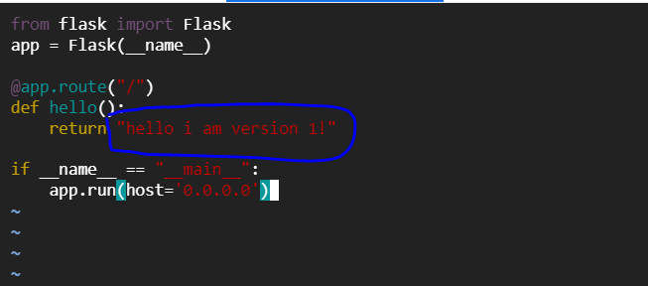

### **Step 5 Run app locally**

Manually run the installer and application using the following commands:

pip install -r requirements.txt

python main.py

**Step 6 : verify app is running your host:5000 by clicking on the url below**

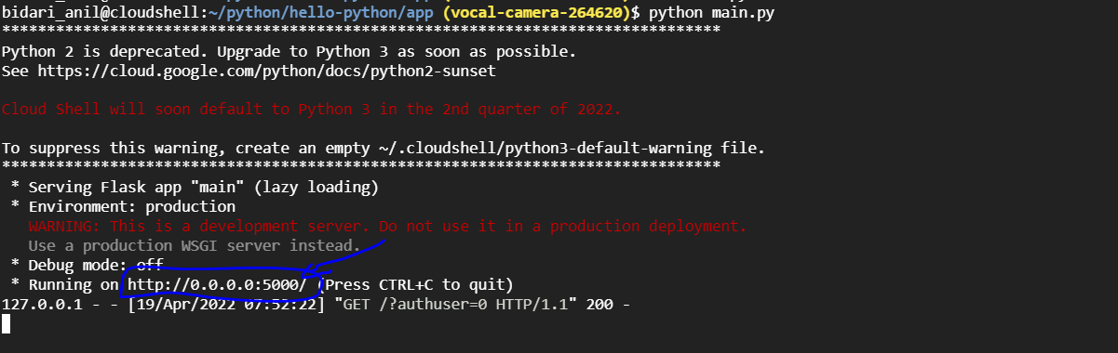

On we browser tab – You will see your app running



**Step-7: We need to enter the Project ID. To check the Project ID. Enter the following command.**

export PROJECT_ID=massive-house-313918

echo $PROJECT_ID

**Step 8 : Then we have to authenticate. Run the below command.**

gcloud auth configure-docker

### **Step 9 : Create a Dockerfile**

Now that you have verified the source code works, the first step in containerizing the application is to create a Dockerfile.

In the hello-python/app directory, create a file named Dockerfile with the following contents and save it:

FROM python:3.7

RUN mkdir /app

WORKDIR /app

ADD . /app/

RUN pip install -r requirements.txt

EXPOSE 5000

CMD ["python", "/app/main.py"]

**Step 10 : build docker image v1**

docker build -t gcr.io/${PROJECT_ID}/python:v1 .

**Step-11: Now we have to push the image. Run the below command.**

docker push gcr.io/${PROJECT_ID}/python:v1

**Step-12: We can see that it is pushed.**

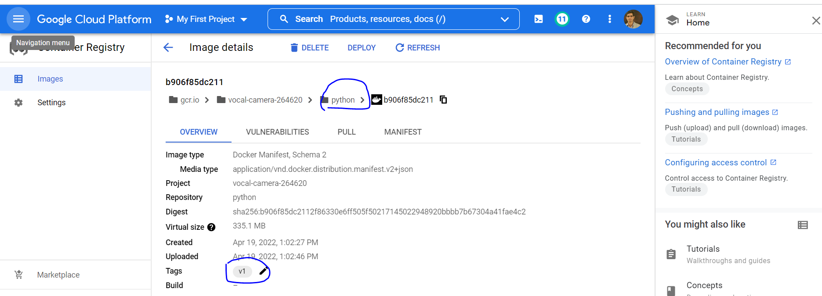

**Step-13 : deploy v1 app as container**

docker run -d --name c1 -p 6001:5000 gcr.io/${PROJECT_ID}/python:v1

**step 14 : verify app1 is running**

curl http://localhost:6001

